**Section 1:**

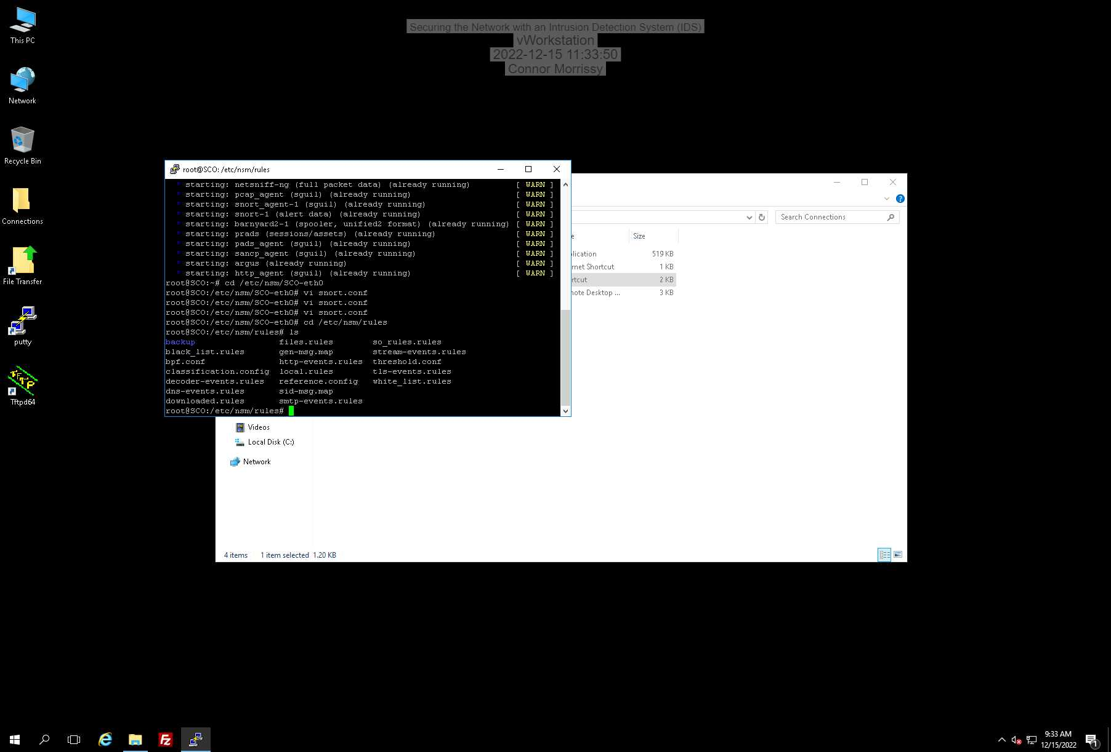

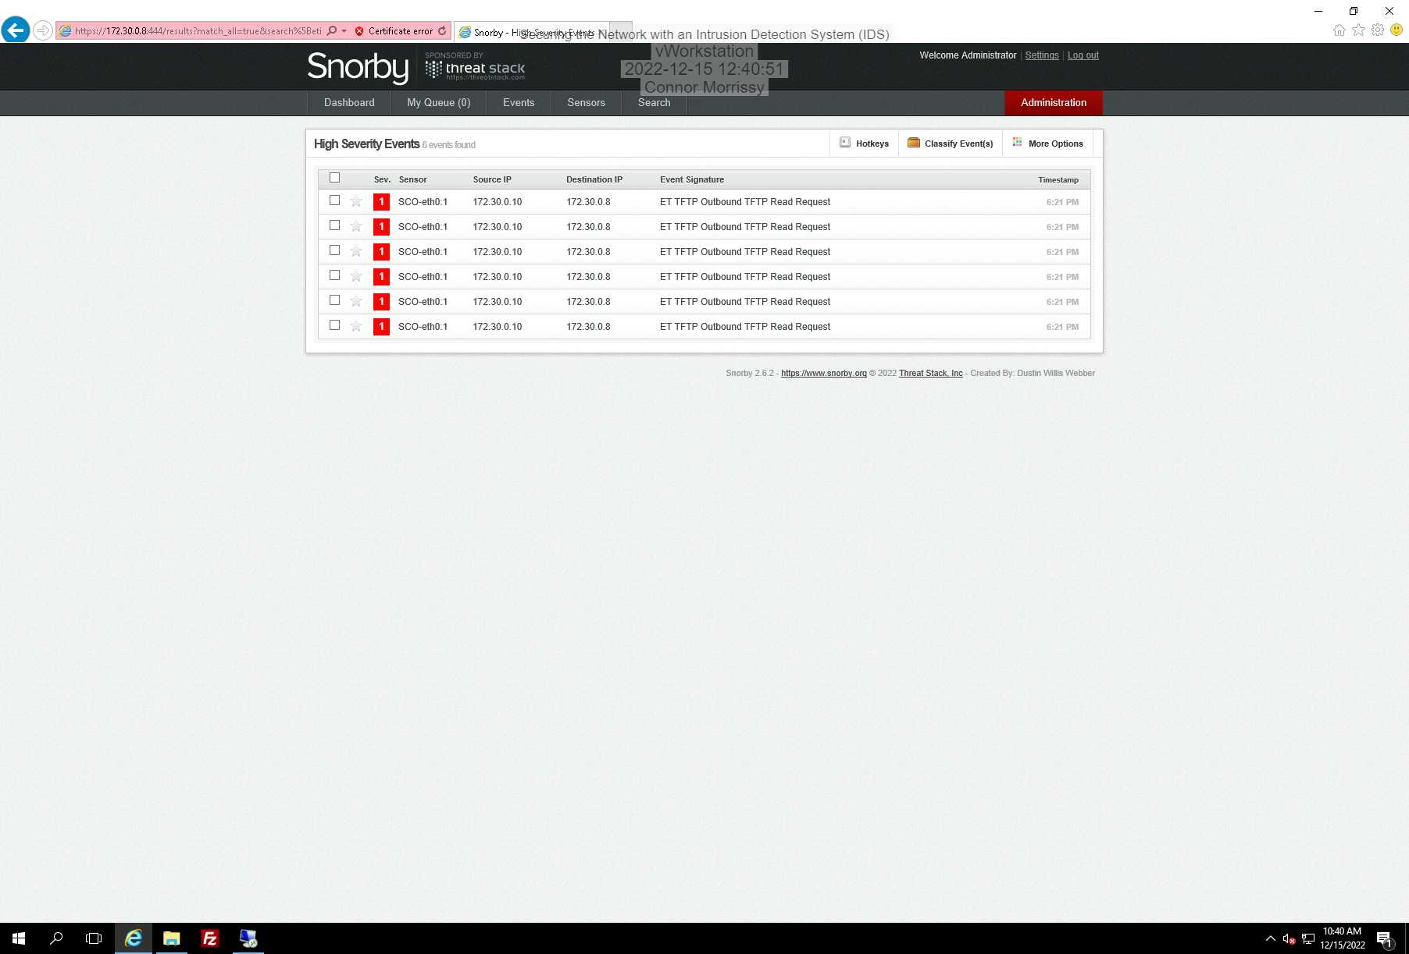

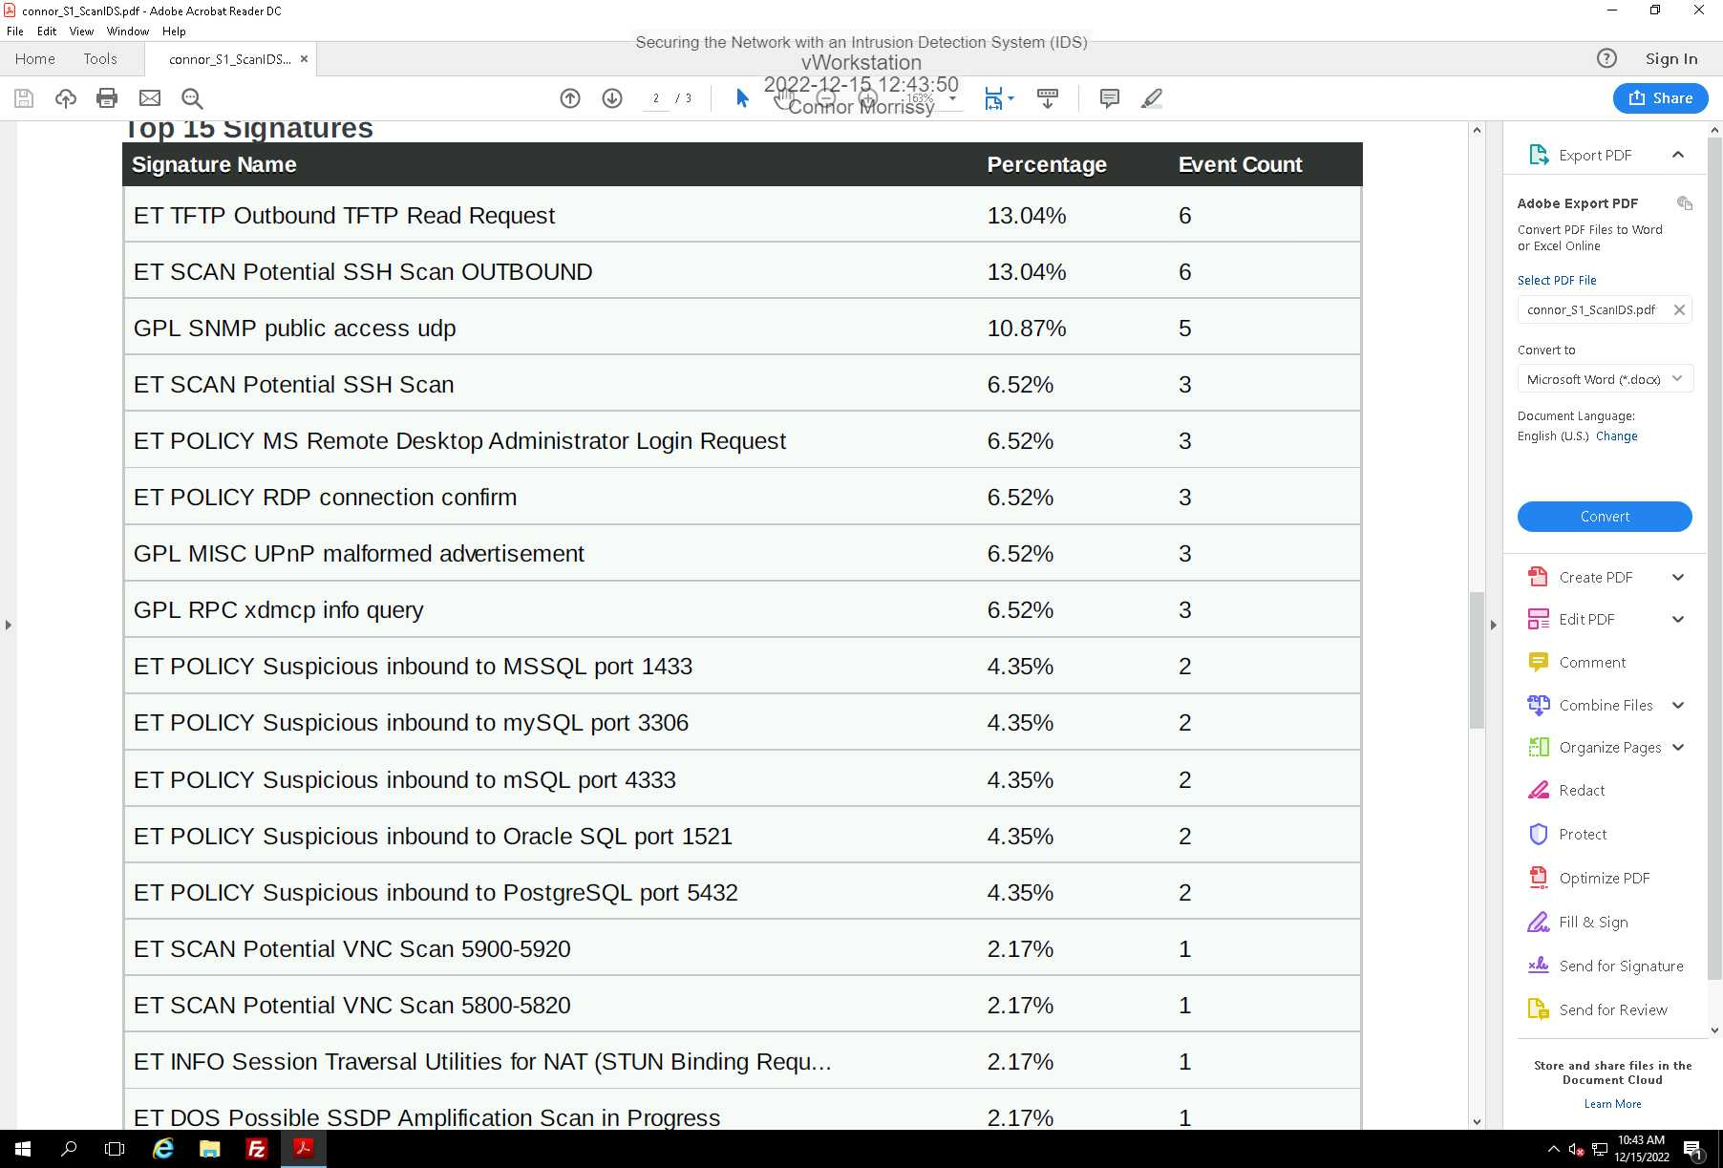

**Section 2:**

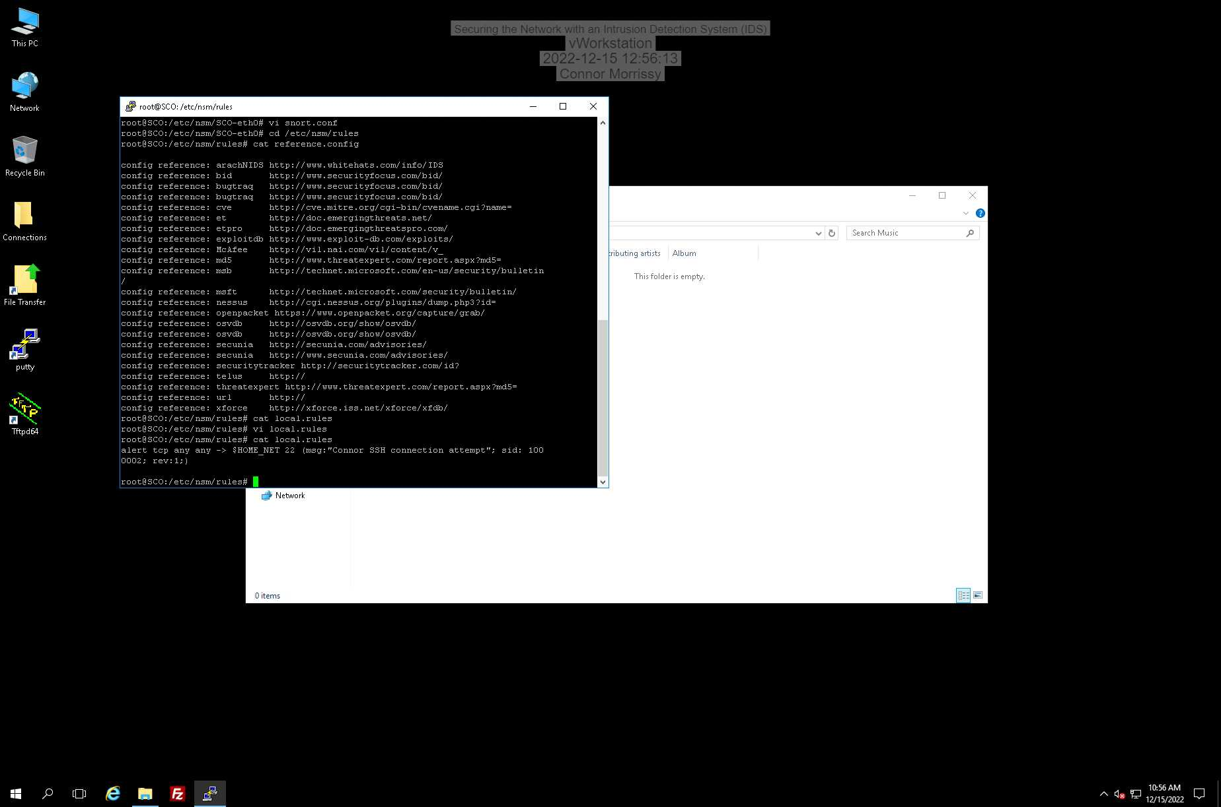

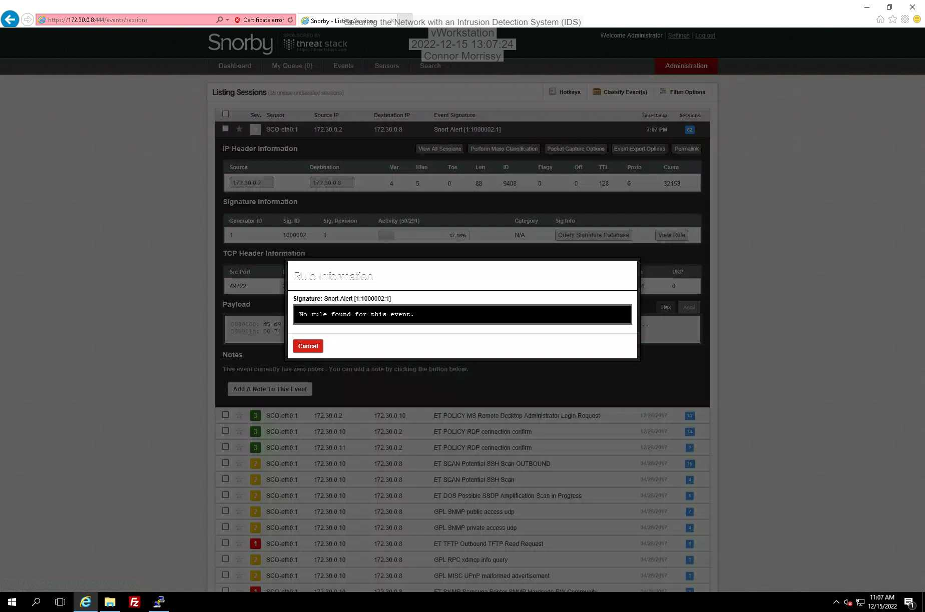

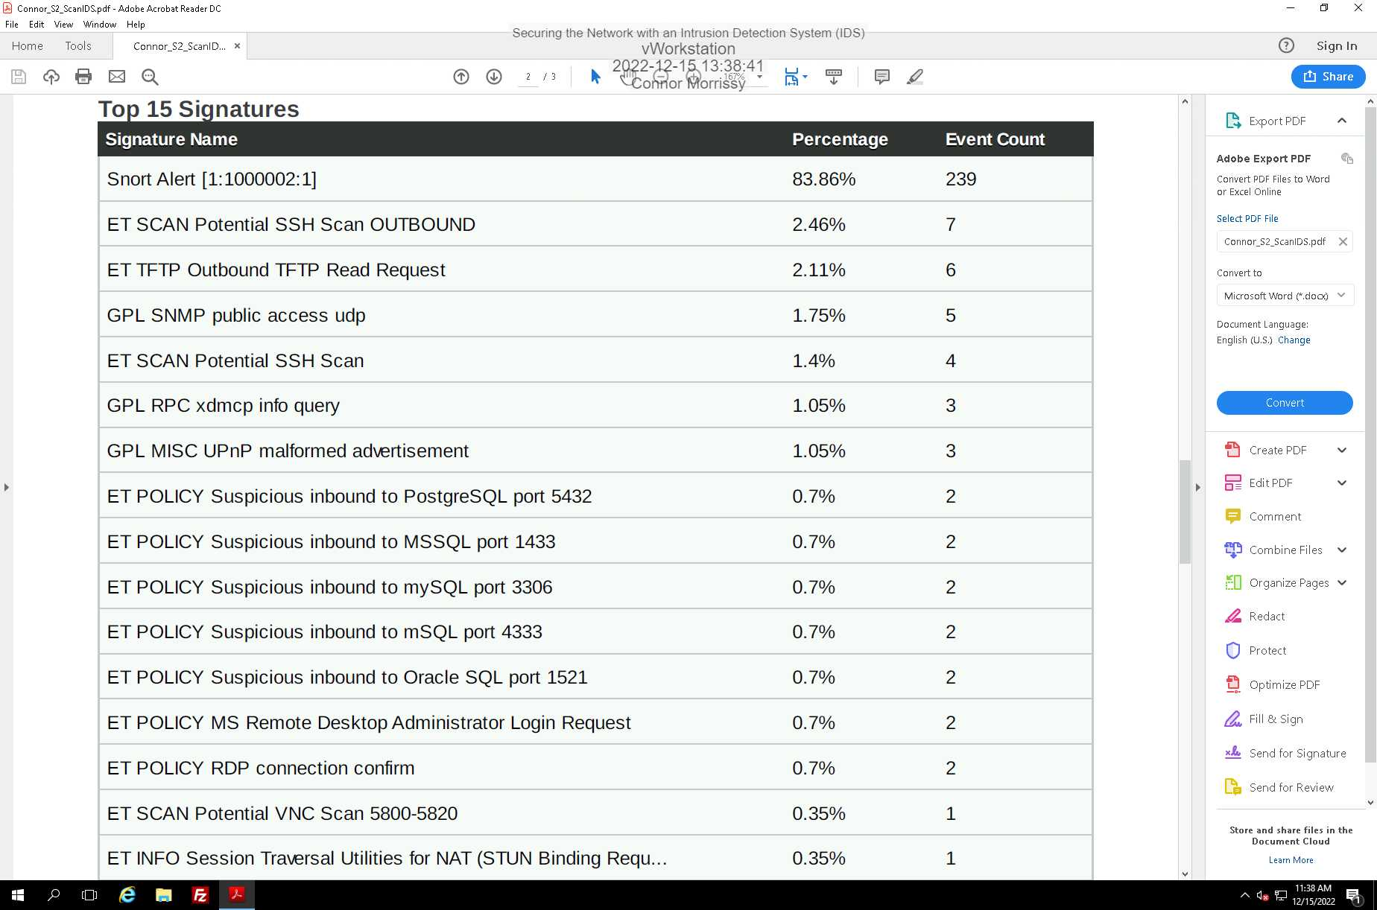

ET SCAN Potential SSH Scan OUTBOUND:

alert tcp $HOME_NET any -> $EXTERNAL_NET 22 (msg:"ET SCAN Potential SSH Scan OUTBOUND"; flow:to_server; flags:S,12; threshold: type threshold, track by_src, count 5, seconds 120; reference:url, en.wikipedia.org/wiki/Brute_force_attack; reference:url,doc.emergingthreats.net/2003068; classtype:attempted-recon; sid:2003068; rev:7; metadata:created_at 2010_07_30, updated_at 2010_07_30;)

ET TFTP Outbound TFTP Read Request:

alert udp $HOME_NET any -> [$EXTERNAL_NET,!255.255.255.255] 69 (msg:"ET TFTP Outbound TFTP Read Request"; content:"|00 01|"; depth:2; reference:url,doc.emergingthreats.net/2008120; classtype:policy-violation; sid:2008120; rev:4; metadata:created_at 2010_07_30, updated_at 2017_01_12;)

ET POLICY Suspicious inbound to mySQL port 3306:

alert tcp $EXTERNAL_NET any -> $HOME_NET 3306 (msg:"ET SCAN Suspicious inbound to mySQL port 3306"; flow:to_server; flags:S; threshold: type limit, count 5, seconds 60, track by_src; reference:url,doc.emergingthreats.net/2010937; classtype:bad-unknown; sid:2010937; rev:3; metadata:created_at 2010_07_30, former_category HUNTING, updated_at 2018_03_27;)

**Section 3:**

Part 1: